Uniform and Appearance Policy
Revised November 2020
The following standards must be met by umpires working National Federation of State High School Associations (NFHS) baseball games assigned by Units affiliated with California Baseball Umpires Association (CBUA).
Individual Units within the CBUA may specify more stringent standards, but are NOT authorized to relax or change any standard without prior written approval. Such approval must be requested through the CBUA President, and received from the CBUA Secretary. The request and approval may be made via e-mail.
One key to being a successful umpire is to first look like an umpire. A pleasing personal appearance is invaluable to an umpire. A poorly dressed umpire suffers a loss of creditability the moment he/she walks on the field.
Your uniform should always be cleaned and pressed. The cap of the plate umpire may be either a short or medium bill cap with the cap of the base umpire having a longer bill. For a more professional appearance, it is required that umpires wear fitted rather than adjustable, caps. The plate umpire needs to have, and use: a ball and strike indicator, a plate brush, a protective supporter and cup, a chest protector, shin guards, and a sturdy mask in either the traditional or hockey style, preferably with an extension or throat protector. A watch should only be brought on the field for game management purposes (e.g., time limits for tournament and non-varsity games), have it in your pocket; do not wear it (for obvious reasons). A cell phone is not an acceptable time keeping device for game management purposes.

PLATE UNIFORM
- Black Pullover Jacket
- Black or Light Blue Shirt
(See pictures for acceptable styles)
- Charcoal Gray Pants
- Black Hat (CIF Logo Fitted, if worn)
- Black Belt
- Black Socks
- Umpire Shoes (Hard toed)
- Black or White Undershirt
- CBUA patch on outermost garment
- Black Ball Bag(s)
- Plate gear (mask, shin guards, chest protector and cup held in place by a garment design for that purpose)
BASE UNIFORM
- Black Pullover Jacket
- Black or Light Blue Shirt
(See pictures for acceptable styles)
- Charcoal Gray Pants
- Black Hat (CIF Logo,Fitted)
- Black Belt
- Black Socks
- Umpire Shoes
- Black or White Undershirt
- CBUA patch on outermost garment

- Regarding shirts and jackets/coats:
  - If the plate umpire wears a shirt, the base umpire may wear a matching shirt or a black jacket/coat.
  - If the plate umpire wears a shirt and the base umpire wears a shirt, the shirts shall the same color and style shirt, including sleeve length and piping.
  - If the plate umpire wears a jacket/coat, the base umpire shall wear a matching jacket/coat.
  - If a short sleeve shirt is worn, a long sleeve undershirt shall not be worn.
- Multiple base umpires (e.g., 3 or 4-man crew) shall all wear the same color undershirt (white or black).
- American flags may be worn. If worn, they shall be worn on the upper back middle of the outer garment. The flag should be 2” by 3 ¼” which is the standard size for flags worn on umpire uniforms and be trimmed in gold (not white). Not all umpires on a crew are required to wear an American flag.
- Umpires are required to wear Charcoal Gray pants. Members of a crew must match color as closely as possible.
- A 4 or 6 stitch hat is required. A fitted or flex fit hat is required. An adjustable, one-size-fits-all hat is not acceptable. (Hats must display CIF Logo)
Exception: If a hockey style mask is used, a hat need not be worn.
(Skull hat with CIF Logo approved for plate umpire)
- A 2-stitch hat shall not be used.
- The belt is required to be 1.75 inches in width. A patent leather belt is acceptable.
- All umpires are required to wear Umpire shoes during the regular season and any level of the CIF-SS playoffs. Umpire shoes are defined to be a field or plate umpire shoe that is sold by a reputable umpire supply company. Shoes worn while working the plate shall be of the safety variety with a hard toe. If you have any questions regarding a specific shoe please contact the CBUA Exec. Instructional Chairman.
- The CBUA Standard Patch (black/gold) is required with no Unit variations. The patch is to be worn on the left pocket and approximately the same position for jackets.
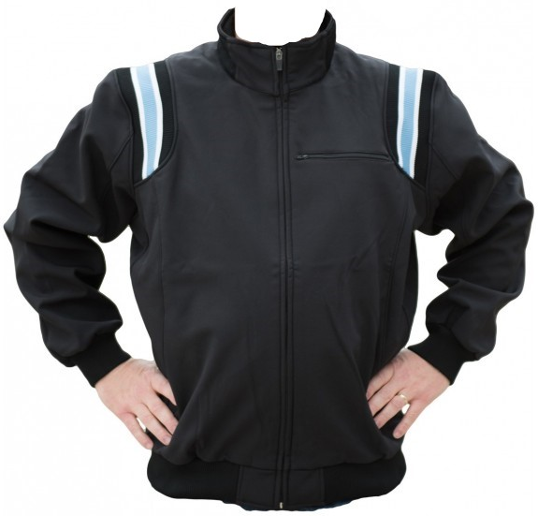
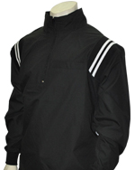
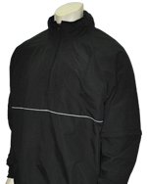
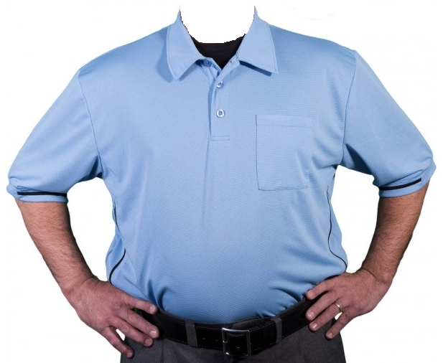
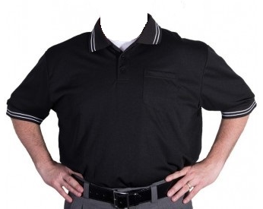
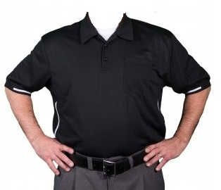
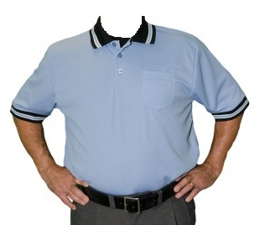
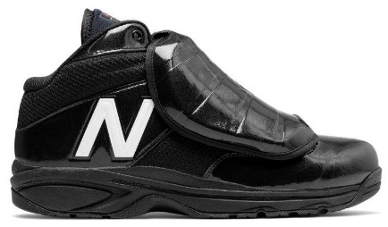
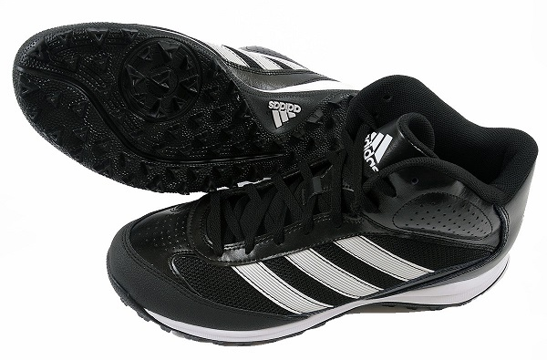
- Umpire crews working CIF-SS semi-final and final games are required to wear black or blue outer garments (shirts or black jackets), hats, belts and ball bags. The piping color and style on jacket must match for entire crew.
ACCEPTABLE
ACCEPTABLE
ACCEPTABLE
ACCEPTABLE
NOT ACCEPTABLE
NOT ACCEPTABLE
ACCEPTABLE
REQUIRED
ACCEPTABLE
ACCEPTABLE
NOT ACCEPTABLE
ACCEPTABLEW
ACCEPTABLE
ACCEPTABLE

